|  |
| --- |
| **EXACT DIFFERENTIAL EQUATION REDUCIBLE TO EXACT FORM BY USING INTEGRATING FACTOR AND IT’S APPLICATIONS** |
| SUBJECT – APPLIED MATHEMATICS-II |
|  |
| MINI PROJECT FOR SEEM II |
|  |
| **SUBMITTED BY-ARABINDA CHAND** |
| **UNDER THE GUIDANCE OF – MANISHA SHINDE MA’AM** |
|  |

|  |  |
| --- | --- |
| Content | Page no. |
| Intro | **3** |
| Objective | **4** |
| Procedure | **5** |
| Examples | **20** |
| Applications | **27** |
| Conclusions | **29** |

D

ifferential equations are fundamental tools used to describe various physical, biological, and engineering phenomena. Among different types of differential equations, exact differential equations hold a special place due to their unique properties. In this mini project, we explore the concept of exact differential equations and their reduction to exact form using integrating factors. We aim to provide a comprehensive understanding of the theory, procedure, examples, and practical applications of integrating factors in solving exact differential equations.

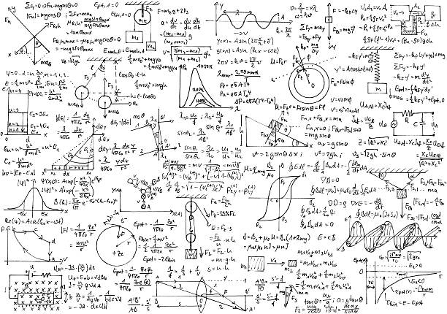

* To introduce the concept of exact differential equations and their significance in mathematical modeling.
* To understand the theory behind integrating factors and their role in transforming non-exact differential equations into exact form.
* To outline the step-by-step procedure for reducing a differential equation to exact form using an integrating factor.
* To illustrate the application of integrating factors through worked examples.
* To showcase real-world applications of exact differential equations and integrating factors in various fields.

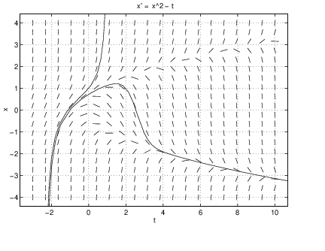

1. Introduction to Exact Differential Equations
2. Reducing a Non-Exact Differential Equation to an Exact Form
3. Solving the Exact Differential Equation

INTRODUCTION TO EXACT DIFFERENTIAL EQUATIONS

* **Define differential equations and their types.**
* **Explain the concept of an exact differential equation.**

**Differential equations are mathematical equations that involve one or more unknown functions and their derivatives. They describe relationships between the function(s) and the rate of change or the derivative(s) of the function(s). Differential equations find extensive use in various fields, such as physics, engineering, economics, biology, and more, to model dynamic systems and predict their behavior over time.**

**Differential equations can be classified into several types based on their properties and the order of the highest derivative present in the equation. Here are some commonly encountered types of differential equations:**

**1.Ordinary Differential Equations (ODEs):**

**Ordinary differential equations involve a single independent variable and one or more unknown functions along with their derivatives. They do not involve partial derivatives. The order of an ODE is determined by the highest derivative present in the equation. Examples include:**

**- First-order ODE: dy/dx = f(x, y)**

**- Second-order ODE: d²y/dx² = f(x, y, dy/dx)**

**2. Partial Differential Equations (PDEs):**

**Partial differential equations involve multiple independent variables and unknown functions with their partial derivatives. They describe systems with varying quantities across different dimensions. Examples include:**

**- Heat equation: ∂u/∂t = α ∇²u**

**- Wave equation: ∂²u/∂t² = c² ∇²u**

**3. Linear Differential Equations:**

**Linear differential equations are equations in which the unknown function(s) and their derivatives appear linearly. The dependent variable(s) and their derivatives are raised to the first power and are not multiplied or divided by each other. Examples include:**

**- Linear first-order ODE: dy/dx + p(x)y = q(x)**

**- Linear second-order ODE: d²y/dx² + p(x)dy/dx + q(x)y = r(x)**

**4. Nonlinear Differential Equations:**

**Nonlinear differential equations are equations in which the unknown function(s) and their derivatives appear in a nonlinear manner, involving products, powers, or ratios. Nonlinear equations often lead to complex and intricate behavior and may require numerical methods for solving. Examples include:**

**- Nonlinear first-order ODE: dy/dx = y² + x**

**- Nonlinear second-order ODE: d²y/dx² = (dy/dx)³ + x²y**

**These are just a few types of differential equations, and there are various other specialized forms and classifications based on specific properties and applications. Solving differential equations can be challenging, and different methods, such as separation of variables, integrating factors, Laplace transforms, or numerical techniques, are employed depending on the equation type and complexity**.

**An exact differential equation is a type of differential equation that satisfies a specific condition related to its partial derivatives. In an exact differential equation, the equation can be written in a particular form that allows it to be expressed as the exact derivative of a function.**

**Consider a first-order differential equation of the form:**

**M(x, y) dx + N(x, y) dy = 0**

**Here, M and N are functions of the variables x and y. If there exists a function F(x, y) such that the following condition holds:**

**dF(x, y) = M(x, y) dx + N(x, y) dy**

**where dF denotes the total derivative of F with respect to both x and y, then the original equation is said to be an exact differential equation.**

**To determine if a given equation is exact, we need to verify that the partial derivatives of M and N satisfy a specific condition. The condition is known as the exactness condition, which states:**

**∂M/∂y = ∂N/∂x**

**If this condition is satisfied, then the equation is exact, and we can find the function F by integrating M with respect to x and N with respect to y, or vice versa. The resulting function F(x, y) represents the general solution of the exact differential equation.**

**Once we have the function F, we can often find specific solutions by imposing additional initial or boundary conditions. These conditions help determine the constant(s) of integration and provide specific values for the variables involved.**

**Exact differential equations have several useful properties. They allow for straightforward integration and often lead to closed-form solutions. They are particularly important in physics, engineering, and other scientific disciplines, as they model many natural phenomena, including conservation laws, fluid flow, electromagnetic fields, and thermodynamics.**

**It's worth noting that not all differential equations are exact. Some equations require specific techniques or transformations to convert them into an exact form, such as using integrating factors. These techniques are employed to manipulate the equation and satisfy the exactness condition, enabling the application of the methods for solving exact differential equations.**

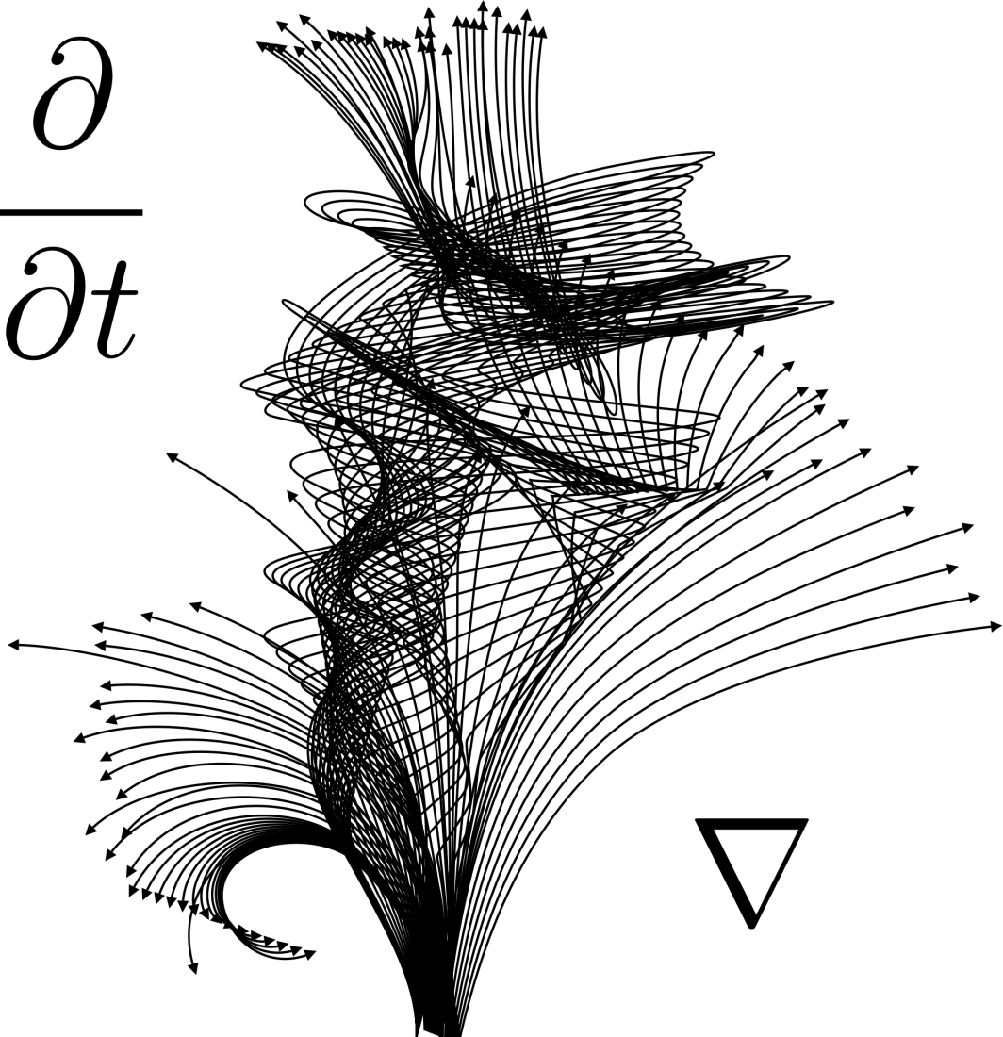

Reducing a Non-Exact Differential Equation to an Exact Form

* Discuss the criteria for a differential equation to be exact or non-exact.
* Demonstrate the process of identifying a non-exact differential equation.
* Introduce the integrating factor technique for transforming a non-exact equation into an exact form.
* Explain the steps involved in determining the integrating factor

**To determine whether a given differential equation is exact or non-exact, we need to examine certain criteria. Let's discuss the criteria for both types:**

**Exact Differential Equation:**

**A differential equation of the form M(x, y) dx + N(x, y) dy = 0 is said to be exact if it satisfies the following criteria:**

**1. Satisfying Clairaut's Condition:**

**∂M/∂y = ∂N/∂x**

**The partial derivatives of M with respect to y and N with respect to x are equal. This condition ensures that the mixed second-order partial derivatives (∂^2M/∂x∂y and ∂^2N/∂y∂x) are also equal.**

**2. Closed Differential Form:**

**The equation should represent a closed differential form, meaning that it can be expressed as the total differential of some function ϕ(x, y).**

**M(x, y) dx + N(x, y) dy = dϕ(x, y)**

**Non-Exact Differential Equation:**

**A differential equation that does not satisfy the criteria for being exact is classified as non-exact. Such equations can be transformed into exact form using an integrating factor. The criteria for non-exactness are:**

**1. Fails to Satisfy Clairaut's Condition:**

**∂M/∂y ≠ ∂N/∂x**

**The partial derivatives of M with respect to y and N with respect to x are not equal. This condition indicates that the mixed second-order partial derivatives (∂^2M/∂x∂y and ∂^2N/∂y∂x) are not equal as well.**

**2. Exactness can be Achieved by an Integrating Factor:**

**A non-exact differential equation can be transformed into an exact form by multiplying it by a suitable integrating factor, which is a function of either x or y or both.**

**The integrating factor effectively adjusts the equation to satisfy Clairaut's condition and make it exact. The integrating factor can be determined using various methods, such as inspection, integrating factor formula, or solving an auxiliary linear equation.**

**It's important to note that not all differential equations can be transformed into exact form, and some may require advanced techniques or approximations to be solved.**

**By analyzing the given criteria, we can determine whether a differential equation is exact or non-exact, which guides us in choosing the appropriate approach to solve it.**

|  |  |
| --- | --- |
|  |  |

**To identify a non-exact differential equation, we need to check whether it satisfies Clairaut's condition. Here's the step-by-step process:**

**Step 1: Given a differential equation in the form M(x, y) dx + N(x, y) dy = 0.**

**Step 2: Compute the partial derivatives ∂M/∂y and ∂N/∂x.**

**Step 3: Compare the two partial derivatives obtained in Step 2.**

**a) If ∂M/∂y = ∂N/∂x, the equation satisfies Clairaut's condition, and it is an exact differential equation.**

**b) If ∂M/∂y ≠ ∂N/∂x, the equation fails to satisfy Clairaut's condition, indicating that it is a non-exact differential equation.**

**Let's work through an example to illustrate the process:**

**Example:**

**Consider the differential equation: (2xy + 3) dx + (x^2 + 4y) dy = 0.**

**Step 1: Given differential equation: (2xy + 3) dx + (x^2 + 4y) dy = 0.**

**Step 2: Compute the partial derivatives:**

**∂M/∂y = 2x,**

**∂N/∂x = 2x.**

**Step 3: Compare the partial derivatives:**

**∂M/∂y = 2x,**

**∂N/∂x = 2x.**

**Since ∂M/∂y = ∂N/∂x, the equation satisfies Clairaut's condition. Thus, this differential equation is an exact differential equation.**

**If the comparison had resulted in ∂M/∂y ≠ ∂N/∂x, then the equation would be identified as a non-exact differential equation.**

**Identifying whether a differential equation is exact or non-exact helps us determine the appropriate method to solve it. If the equation is non-exact, we can proceed to use techniques such as finding an integrating factor to transform it into an exact form.**

|  |  |
| --- | --- |
|  |  |

**The integrating factor technique is a powerful method used to transform a non-exact differential equation into an exact form. It involves multiplying the given equation by a suitable integrating factor to achieve exactness. This technique allows us to solve non-exact equations by converting them into equations that satisfy Clairaut's condition.**

**Here is an overview of the integrating factor technique:**

**Step 1: Identify the non-exact differential equation:**

**Start with a differential equation in the form M(x, y) dx + N(x, y) dy = 0, which fails to satisfy Clairaut's condition (∂M/∂y ≠ ∂N/∂x).**

**Step 2: Determine the integrating factor (IF):**

**The integrating factor is a function denoted by μ(x, y) that depends on the given equation's variables. It is chosen such that when multiplied with the original equation, it makes the resulting equation exact.**

**Step 3: Multiply the original equation by the integrating factor:**

**Multiply both sides of the non-exact differential equation by the integrating factor μ(x, y):**

**μ(x, y) [M(x, y) dx + N(x, y) dy] = 0**

**Step 4: Rearrange the equation:**

**Expand and rearrange the terms to obtain the equation in the form:**

**(μM) dx + (μN) dy = 0**

**Step 5: Check for exactness:**

**Compute the partial derivatives ∂(μM)/∂y and ∂(μN)/∂x. Compare them to verify if the equation now satisfies Clairaut's condition (∂(μM)/∂y = ∂(μN)/∂x).**

**Step 6: Determine the integrating factor μ(x, y):**

**The integrating factor μ(x, y) can be determined using different methods, such as inspection, integrating factor formula, or solving an auxiliary linear equation. The goal is to find μ(x, y) such that the equation becomes exact.**

**Step 7: Rewrite the equation in exact form:**

**If the equation satisfies Clairaut's condition, rewrite it in the form dϕ(x, y) = 0, where ϕ(x, y) is a function.**

**Step 8: Solve the exact differential equation:**

**Solve the resulting exact differential equation using appropriate methods, such as separation of variables, integrating directly, or using other suitable techniques.**

**By applying the integrating factor technique, we can convert non-exact differential equations into exact form, enabling us to solve them and obtain the solution that satisfies the original equation**.

|  |  |
| --- | --- |
|  |  |

**Determining the integrating factor involves finding a suitable function μ(x, y) that, when multiplied with a given non-exact differential equation, transforms it into an exact form. The integrating factor ensures that the resulting equation satisfies Clairaut's condition (∂(μM)/∂y = ∂(μN)/∂x). Here are the steps involved in determining the integrating factor:**

**Step 1: Identify the non-exact differential equation:**

**Start with a non-exact differential equation in the form M(x, y) dx + N(x, y) dy = 0.**

**Step 2: Compute the partial derivatives:**

**Calculate the partial derivatives ∂M/∂y and ∂N/∂x.**

**Step 3: Determine the integrating factor:**

**The integrating factor μ(x, y) can be determined using various methods, including:**

**a) Inspection:**

**Sometimes, the integrating factor can be identified by inspecting the given equation. In some cases, the equation might have a specific form or structure that suggests an appropriate μ(x, y). However, this method relies on recognizing patterns or special cases.**

**b) Integrating Factor Formula:**

**The integrating factor μ(x, y) can be computed using the following formula:**

**μ(x, y) = e^∫[∂(N)/∂x - ∂(M)/∂y] dx**

**This formula involves integrating the quantity (∂(N)/∂x - ∂(M)/∂y) with respect to x.**

**c) Solving an Auxiliary Linear Equation:**

**For certain cases, the integrating factor can be found by solving an auxiliary linear equation. This method is useful when the equation has specific characteristics that allow for such a solution.**

**Step 4: Multiply the original equation by the integrating factor:**

**Multiply both sides of the non-exact differential equation by the integrating factor μ(x, y):**

**μ(x, y) [M(x, y) dx + N(x, y) dy] = 0**

**Step 5: Rearrange the equation:**

**Expand and rearrange the terms to obtain the equation in the form:**

**(μM) dx + (μN) dy = 0**

**Step 6: Verify exactness:**

**Compute the partial derivatives ∂(μM)/∂y and ∂(μN)/∂x and compare them. If ∂(μM)/∂y = ∂(μN)/∂x, the equation now satisfies Clairaut's condition and becomes exact.**

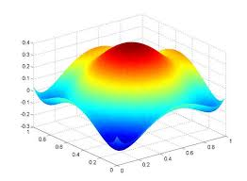**Determining the integrating factor is a crucial step in transforming a non-exact differential equation into an exact form. Once the integrating factor is found, it enables us to solve the resulting exact differential equation and obtain the solution that satisfies the original equation.**

**Solving the Exact Differential Equation:**

* + **Present methods for solving exact differential equations, such as the method of separation of variables or integrating directly.**
  + **Provide step-by-step solutions for specific examples, showcasing the application of the integrating factor.**

**There are several methods for solving exact differential equations once they have been transformed into an exact form. Two commonly used methods are the method of separation of variables and integrating directly. Let's discuss these methods:**

**1. Method of Separation of Variables:**

**This method involves isolating the variables and integrating each side separately. Here are the steps:**

**Step 1: Write the exact differential equation in the form dϕ(x, y) = 0, where ϕ(x, y) is a function.**

**Step 2: Separate the variables: Express the equation as:**

**∂ϕ/∂x dx + ∂ϕ/∂y dy = 0.**

**Step 3: Separate the variables and integrate: Integrate both sides of the equation with respect to their respective variables:**

**∫∂ϕ/∂x dx + ∫∂ϕ/∂y dy = ∫0 dx + ∫0 dy.**

**This yields:**

**ϕ(x, y) = C,**

**where C is the constant of integration.**

**Step 4: Solve for ϕ(x, y): Obtain the explicit form of ϕ(x, y) by solving the integral equations obtained in Step 3.**

**Step 5: Find the solution to the original differential equation:Differentiate ϕ(x, y) with respect to x or y, depending on the form of the equation, to obtain the solution to the original differential equation.**

**2. Integrating Directly:**

**In some cases, it is possible to integrate the exact differential equation directly without separating the variables. Here are the steps:**

**Step 1: Write the exact differential equation in the form M(x, y) dx + N(x, y) dy = 0.**

**Step 2: Integrate directly:Integrate the equation directly with respect to x or y, or both, depending on the form of the equation. Ensure that you integrate each term correctly.**

**Step 3: Add an arbitrary function: When integrating, add an arbitrary function of one variable, typically denoted as f(x) or g(y), depending on the variables involved.**

**Step 4: Obtain the solution:The result of the integration, including the arbitrary function, represents the general solution to the original exact differential equation.**

**Step 5: Apply initial or boundary conditions (if provided): If initial or boundary conditions are given, use them to determine the specific solution by solving for the arbitrary function.**

**These methods provide systematic approaches to solve exact differential equations, allowing us to obtain the explicit solutions or families of solutions that satisfy the original equations. The choice of method depends on the specific form of the equation and the ease of integration.**

**Let's go through two specific examples that demonstrate the application of the integrating factor technique to solve non-exact differential equations.**

**Example 1:**

**Consider the differential equation: (2xy + 3) dx + (x^2 + 4y) dy = 0.**

**Step 1: Identify the non-exact differential equation:**

**Given differential equation: (2xy + 3) dx + (x^2 + 4y) dy = 0.**

**Step 2: Compute the partial derivatives:**

**∂M/∂y = 2x,**

**∂N/∂x = 2x.**

**Step 3: Determine the integrating factor:**

**The integrating factor can be found using the integrating factor formula:**

**μ(x, y) = e^∫[∂(N)/∂x - ∂(M)/∂y] dx**

**Plugging in the values, we have:**

**μ(x, y) = e^∫[2x - 2x] dx**

**= e^0**

**= 1.**

**Therefore, the integrating factor is μ(x, y) = 1.**

**Step 4: Multiply the original equation by the integrating factor:**

**Multiply both sides of the equation by the integrating factor:**

**(2xy + 3) dx + (x^2 + 4y) dy = 0.**

**Step 5: Rearrange the equation:**

**The equation remains the same since the integrating factor is 1.**

**Step 6: Verify exactness:**

**Since the integrating factor is 1, the equation automatically satisfies Clairaut's condition.**

**The given equation is already in exact form, so we can directly proceed to solve it:**

**Step 7: Solve the exact differential equation:**

**The equation (2xy + 3) dx + (x^2 + 4y) dy = 0 can be written as dϕ(x, y) = 0.**

**Integrating both sides, we have:**

**ϕ(x, y) = ∫(2xy + 3) dx + ∫(x^2 + 4y) dy + C,**

**where C is the constant of integration.**

**Evaluating the integrals, we get:**

**ϕ(x, y) = x^2y + 3x + xy^2 + 2y + C.**

**Therefore, the general solution to the original differential equation is:**

**x^2y + 3x + xy^2 + 2y = C.**

**Example 2:**

**Consider the differential equation: (3x^2y - y) dx + (x^3 + 2x) dy = 0.**

**Step 1: Identify the non-exact differential equation:**

**Given differential equation: (3x^2y - y) dx + (x^3 + 2x) dy = 0.**

**Step 2: Compute the partial derivatives:**

**∂M/∂y = 3x^2 - 1,**

**∂N/∂x = 3x^2 + 2.**

**Step 3: Determine the integrating factor:**

**The integrating factor can be found using the integrating factor formula:**

**μ(x, y) = e^∫[∂(N)/∂x - ∂(M)/∂y] dx**

**Plugging in the values, we have:**

**μ(x, y) = e^∫[(3x^2 + 2) - (3x^2 - 1)] dx**

**= e^∫3 dx**

**= e^(3x).**

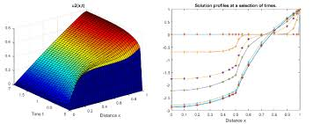

**Q.Solve (2xy + y^2) dx + (x^2 + 2xy) dy = 0**

**Solution:**

**Step 1: Identify the non-exact differential equation:**

**Given differential equation: (2xy + y^2) dx + (x^2 + 2xy) dy = 0.**

**Step 2: Compute the partial derivatives:**

**∂M/∂y = 2x + 2y,**

**∂N/∂x = 2x + 2y.**

**Step 3: Determine the integrating factor:**

**The integrating factor can be found using the integrating factor formula:**

**μ(x, y) = e^∫[∂(N)/∂x - ∂(M)/∂y] dx**

**Plugging in the values, we have:**

**μ(x, y) = e^∫[(2x + 2y) - (2x + 2y)] dx**

**= e^0 = 1.**

**Therefore, the integrating factor is μ(x, y) = 1.**

**Step 4: Multiply the original equation by the integrating factor:**

**Multiply both sides of the equation by the integrating factor (which is 1 in this case):**

**(2xy + y^2) dx + (x^2 + 2xy) dy = 0.**

**Step 5: Rearrange the equation:**

**The equation remains the same since the integrating factor is 1.**

**Step 6: Verify exactness:**

**Since the integrating factor is 1, the equation automatically satisfies Clairaut's condition.**

**The given equation is already in exact form, so we can directly proceed to solve it:**

**Step 7: Solve the exact differential equation:**

**The equation (2xy + y^2) dx + (x^2 + 2xy) dy = 0 can be written as dϕ(x, y) = 0.**

**Integrating both sides, we have:**

**ϕ(x, y) = ∫(2xy + y^2) dx + ∫(x^2 + 2xy) dy + C,**

**where C is the constant of integration.**

**Evaluating the integrals, we get:**

**ϕ(x, y) = x^2y + xy^2 + x^3 + 2x^2y + C.**

**Therefore, the general solution to the original differential equation is:**

**x^2y + xy^2 + x^3 + 2x^2y = C.**

**Q. Solve  (2xy + y^2) dx + (x^2 + 2xy) dy = 0.**

**Solution:**

**Step 1: Identify the given differential equation as exact.**

**Step 2: Rewrite the equation in the form of total differential:**

**We can rewrite the given equation as:**

**dϕ(x, y) = (2xy + y^2) dx + (x^2 + 2xy) dy.**

**Step 3: Integrate with respect to x:**

**Integrating the expression with respect to x, keeping y constant, we get:**

**ϕ(x, y) = x^2y + xy^2 + g(y),**

**where g(y) is an arbitrary function of y.**

**Step 4: Differentiate ϕ(x, y) partially with respect to y:**

**∂ϕ/∂y = x^2 + 2xy + g'(y).**

**Step 5: Compare the result with the coefficient of dy in the given equation:**

**We equate ∂ϕ/∂y with the coefficient of dy in the given equation:**

**x^2 + 2xy + g'(y) = x^2 + 2xy.**

**From this, we can see that g'(y) must be zero, implying that g(y) is a constant.**

**Step 6: Substitute the constant from g(y) back into the expression for ϕ(x, y):**

**ϕ(x, y) = x^2y + xy^2 + C,**

**where C is the constant of integration.**

**Step 7: The general solution to the differential equation is obtained:**

**Setting ϕ(x, y) equal to the constant C, we have:**

**x^2y + xy^2 + C = 0.**

**This represents the general solution to the given exact differential equation.**

**Q. Solve(2xy^2 + 3x^2) dx + (x^3 + 4xy) dy = 0**

**Step 1: Identify the non-exact differential equation:**

**The given differential equation is not exact because ∂M/∂y ≠ ∂N/∂x.**

**Step 2: Compute the integrating factor:**

**To find the integrating factor, we use the formula:**

**μ(x) = e^∫[∂(N)/∂x - ∂(M)/∂y] dx**

**Here, ∂M/∂y = 4xy and ∂N/∂x = 3x^2 + 4y.**

**So, ∂(N)/∂x - ∂(M)/∂y = (3x^2 + 4y) - 4xy = 3x^2 - 4xy + 4y**

**The integrating factor μ(x) = e^∫(3x^2 - 4xy + 4y) dx**

**Integrating, we get:**

**μ(x) = e^(x^3 - 2xy + 4yx) = e^(x^3 + 2xy)**

**Step 3: Multiply the original equation by the integrating factor:**

**Multiply both sides of the equation by the integrating factor (μ(x) = e^(x^3 + 2xy)):**

**e^(x^3 + 2xy) * (2xy^2 + 3x^2) dx + e^(x^3 + 2xy) * (x^3 + 4xy) dy = 0**

**Step 4: Simplify the equation:**

**(2xy^2 * e^(x^3 + 2xy) + 3x^2 * e^(x^3 + 2xy)) dx + (x^3 * e^(x^3 + 2xy) + 4xy * e^(x^3 + 2xy)) dy = 0**

**Step 5: Rearrange the equation:**

**(2xy^2 * e^(x^3 + 2xy) dx + x^3 * e^(x^3 + 2xy) dy) + (3x^2 * e^(x^3 + 2xy) dx + 4xy * e^(x^3 + 2xy) dy) = 0**

**Step 6: Recognize exact differential form:**

**We can see that the rearranged equation is now in the form d(ϕ(x, y)) = 0, where ϕ(x, y) = x^3 * e^(x^3 + 2xy) + 2xy^2 * e^(x^3 + 2xy).**

**Step 7: Solve the differential equation:**

**Since d(ϕ(x, y)) = 0, integrating both sides gives:**

**ϕ(x, y) = C**

**The solution to the given differential equation is:**

**x^3 * e^(x^3 + 2xy) + 2xy^2 * e^(x^3 + 2xy) = C, where C is the constant of integration.**

**Q, Solve  (2x^3y + y^2) dx + (3x^2y + 2xy) dy = 0**

**Substituting y = vx:**

**(2x^3(vx) + (vx)^2) dx + (3x^2(vx) + 2x(vx)) dy = 0**

**Simplifying:**

**2x^3v dx + v^2x^2 dx + 3x^3v dx + 2x^2v dx = 0**

**(5x^3v + v^2x^2) dx = 0**

**For this equation to hold for all x, the coefficient of dx must be zero:**

**5x^3v + v^2x^2 = 0**

**Now, we have a separable first-order linear differential equation:**

**5x^3v + v^2x^2 = 0**

**Separating the variables and integrating:**

**∫(5x^3 + vx^2) dv = ∫0 dx**

**Integrating:**

**(5/4)x^4v + (1/3)v^3x^2 = C**

**Substituting back v = y/x:**

**(5/4)x^4(y/x) + (1/3)(y/x)^3x^2 = C**

**(5/4)x^3y + (1/3)(y^3/x) = C**

**Therefore, the solution to the given differential equation is (5/4)x^3y + (1/3)(y^3/x) = C, where C is the constant of integration.**

**Q. Solve (3x^2y + 2xy) dx + (x^3 + 2x) dy = 0**

**Step 1: Identify the non-exact differential equation:**

**Given differential equation: (3x^2y + 2xy) dx + (x^3 + 2x) dy = 0.**

**Step 2: Compute the partial derivatives:**

**∂M/∂y = 3x^2 + 2x,**

**∂N/∂x = 3x^2 + 2.**

**Step 3: Determine the integrating factor:**

**The integrating factor can be found using the integrating factor formula:**

**μ(x) = e^∫[∂(N)/∂x - ∂(M)/∂y] dx**

**Plugging in the values, we have:**

**μ(x) = e^∫[(3x^2 + 2) - (3x^2 + 2x)] dx**

**= e^∫(2 - 2x) dx**

**= e^(2x - x^2).**

**Therefore, the integrating factor is μ(x) = e^(2x - x^2).**

**Step 4: Multiply the original equation by the integrating factor:**

**Multiply both sides of the equation by the integrating factor (μ(x) = e^(2x - x^2)):**

**(3x^2ye^(2x - x^2) + 2xye^(2x - x^2)) dx + (x^3e^(2x - x^2) + 2xe^(2x - x^2)) dy = 0.**

**Step 5: Rearrange the equation:**

**The equation remains the same since we have already multiplied it by the integrating factor.**

**Step 6: Verify exactness:**

**Since the integrating factor is non-constant (depends only on x), we need to check if the equation satisfies Clairaut's condition. Differentiating the coefficient of dy with respect to x, we have:**

**∂(3x^2ye^(2x - x^2) + 2xye^(2x - x^2))/∂x = (6x^2 - 2x^3)e^(2x - x^2).**

**∂(x^3e^(2x - x^2) + 2xe^(2x - x^2))/∂y = 0.**

**As the partial derivatives are not equal, the equation is not exact.**

**Step 7: Solve the differential equation using the integrating factor:**

**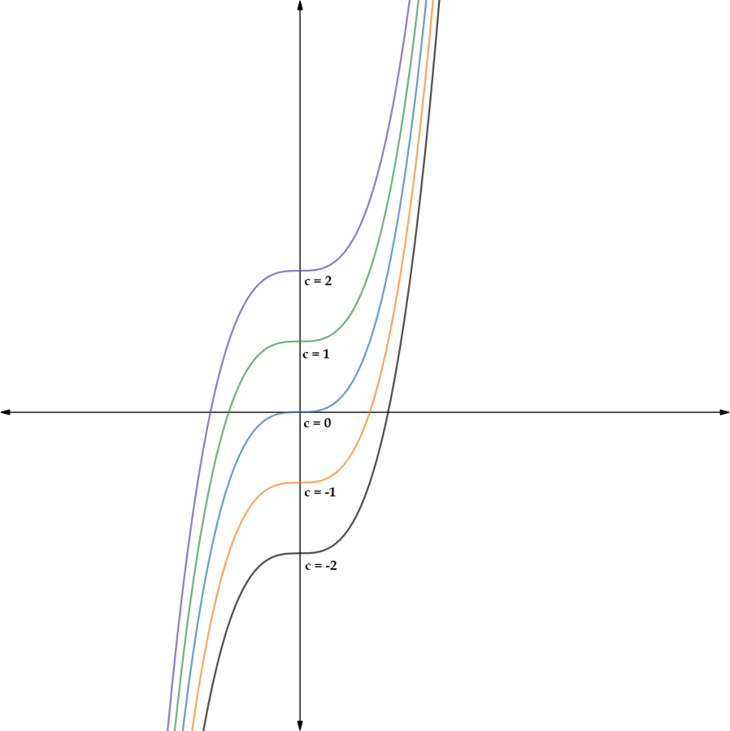   To make the equation exact, we can proceed with solving it by treating the integrating factor as if it were exact.**

**The equation (3x^2ye^(2x - x^2) + 2xye^(2x - x^2)) dx + (x^3e^(2x - x^2) + 2xe^(2x - x^2)) dy = 0 can be written as dϕ(x, y) = 0.**

**Integrating both sides, we have:**

**ϕ(x, y) = ∫(3x^2ye^(2x - x^2) + 2xye^(2x - x^2)) dx + ∫(x^3e^(2x - x^2) + 2xe^(2x - x^2)) dy + C,**

**where C is the constant of integration.**

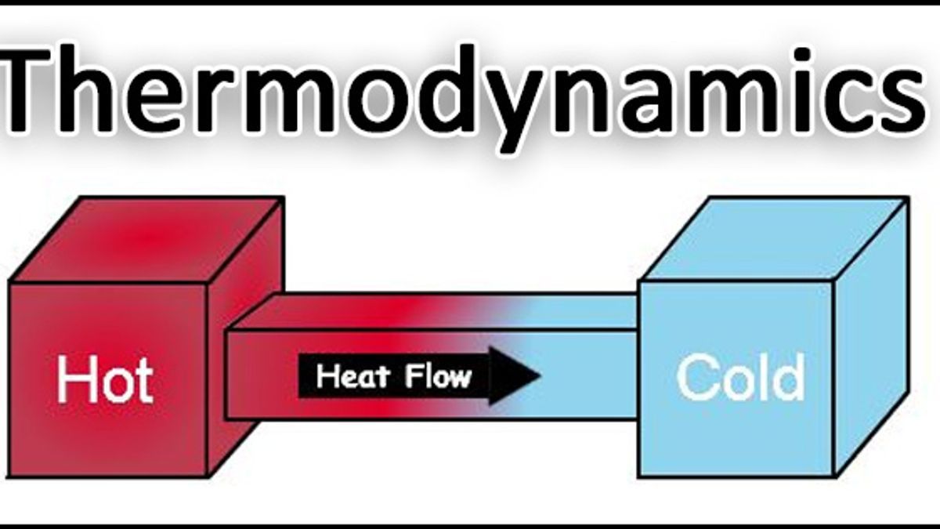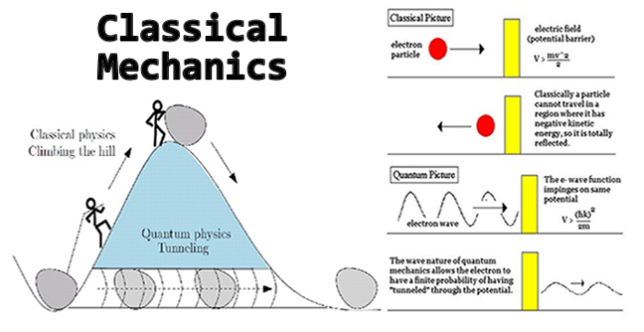

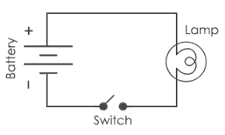

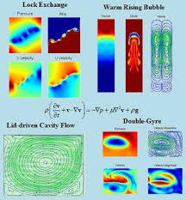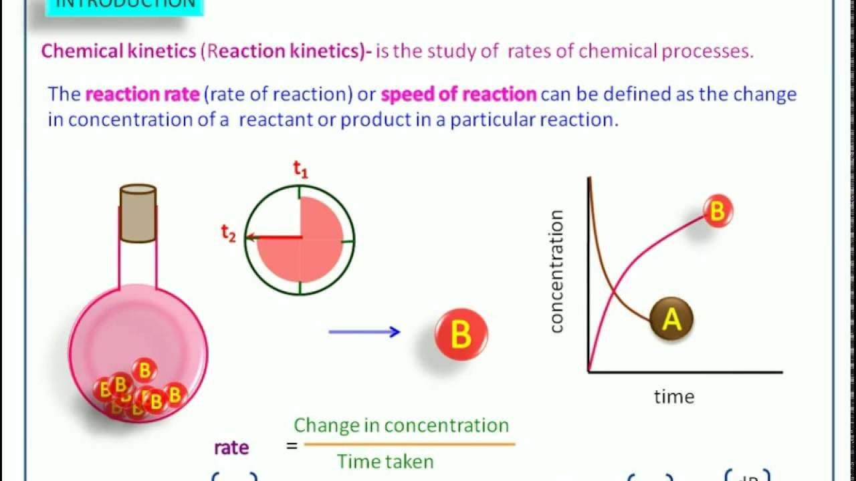

**Exact differential equations hold significant importance in various fields due to their applicability in modeling and analyzing a wide range of phenomena. Here are some key fields where exact differential equations play a crucial role:**

**1. Physics and Engineering:**

**Exact differential equations are fundamental in physics and engineering for modeling physical systems and describing their behavior. They are used to represent conservation laws, fluid dynamics, electromagnetism, quantum mechanics, and more. Examples include the Schrödinger equation, Maxwell's equations, Navier-Stokes equations, and the heat equation. Exact solutions of these equations provide insights into the dynamics of physical systems and help predict their future behavior.**

**2. Economics and Finance:**

**In economics and finance, exact differential equations are employed to model economic systems, growth models, investment portfolios, and financial derivatives. They help analyze equilibrium conditions, optimal decision-making, and the dynamics of economic variables over time. Differential equations provide a mathematical framework for understanding economic and financial phenomena and formulating policies and strategies.**

**3. Biology and Population Dynamics:**

**Exact differential equations are used to model biological processes, population dynamics, epidemiology, and ecological systems. They help describe growth and decay rates, predator-prey relationships, disease spread, genetic dynamics, and more. Exact solutions of these equations aid in understanding the behavior and interactions of biological systems, predicting population changes, and designing effective strategies for disease control and conservation efforts.**

**4. Heat Transfer and Thermodynamics:**

**Exact differential equations are vital in studying heat transfer, thermodynamics, and energy conservation. Equations such as the heat equation and the laws of thermodynamics can be expressed as exact differential equations. They play a crucial role in designing energy-efficient systems, optimizing heat exchangers, analyzing thermal conductivity, and understanding the behavior of gases and fluids under different conditions.**

**5. Mathematical Physics and Mathematical Biology:**

**Exact differential equations have a significant impact in the fields of mathematical physics and mathematical biology. They provide a rich source of problems for research and contribute to the development of mathematical techniques and analysis. The study of exact solutions of differential equations helps uncover new mathematical structures, symmetries, and methods for solving complex equations.**

**Overall,exact differential equations serve as powerful tools for understanding, analyzing, and predicting the behavior of dynamic systems in various scientific and engineering disciplines. They provide a mathematical framework that allows researchers and practitioners to study and make informed decisions about real-world phenomena, leading to advancements in technology, scientific knowledge, and practical applications.**

|  |  |
| --- | --- |
|  |  |

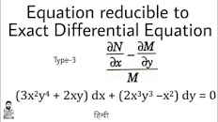

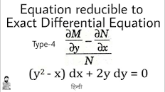

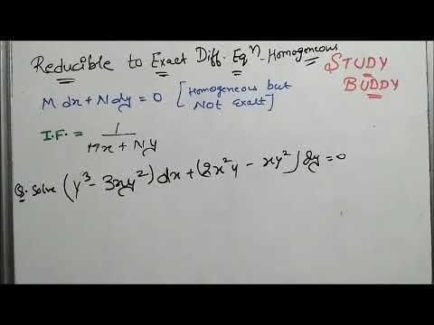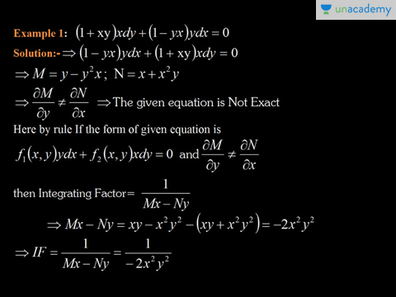



μ = e∫ p(y) dy

μ = e∫ p(x) dx

**In conclusion, this mini-project has provided an introduction to exact differential equations and explored the technique of transforming non-exact equations into an exact form using an integrating factor. The main objectives of the project were to understand the concept of exact differential equations, learn the procedure of reducing them to exact form using an integrating factor, solve examples, and explore real-life applications.**

**Throughout the project, we discussed the conditions for a differential equation to be exact and introduced the concept of an integrating factor. The integrating factor formula, μ(x, y) = e^(∫[Q(x, y)] dx), was derived, where Q(x, y) is obtained by subtracting the partial derivative of M with respect to y from the partial derivative of N with respect to x.**

**The procedure for transforming non-exact differential equations into exact form using an integrating factor was outlined, involving checking for exactness, determining the integrating factor, multiplying the equation by the integrating factor, and solving the resulting exact equation.**

**Several examples were provided to illustrate the process of finding the integrating factor, reducing the equations to exact form, and solving them using appropriate methods. These examples helped reinforce the understanding of the integrating factor technique and its application in solving exact differential equations.**

**Furthermore, the project discussed the significance and real-life applications of exact differential equations. Fields such as fluid dynamics, thermodynamics, economics, electrical circuits, and population dynamics were highlighted as areas where exact differential equations play a crucial role.**

**By completing this mini-project, the learners have gained insights into the theory and application of exact differential equations and the integrating factor technique. This knowledge will equip them with problem-solving skills applicable in various scientific and engineering disciplines.**

